**FP5.0 Module-1**

**Project-1**

**Batch Name:**

Infosys FP5.0 Summer 2018

**Enrollment Number:** R171217041

**SAPID:** 500060720

**Name:** Nishkarsh Raj Khare

**Sem:** Semester-III

**Branch:** CSE-DevOps-Xebia

**Project objectives**

After completing this project, a learner should be able to understand and implement the integration of Python Program and Oracle database and perform basic database queries from Python Application.

* Connecting Python Application to Oracle database
* Control Structures in Python Programming : If / Else, For loop
* Data Structures in Python: Strings, Lists, Tuples, Dictionary
* Functions in Python
* Basic Database Operations and clauses in SQL
  + Select
  + Update
  + Delete
  + Functions
  + Group By and Having

**Specifications**

* The project is to extend the InstaDB project by integrating the Oracle database with a Python program.
* The Python Program should connect to InstaDB and allow the user to perform given queries.
* The data needs to be pulled from multiple tables using SQL queries and logic needs to be written in Python program to join the result from those queries to get the desired result. (However, you will learn a simpler way of achieving the same result in Module 5 using ˜Join" operator.)
* For query Which of my pictures has received maximum likes?:
  + Retrieve pic ids from "Pictures" Table where user-id = myUserId and store them in Python list
  + Iterate over that list, say using For loop of Python, and retrieve no. of likes for each of these pictures from "Likes" table, and store in another list
  + Find and display the picture id with maximum likes
* What needs to be done:
  + Write a Python program that connects to database created in InstaDB project
  + Program should show menu based choices from 1 to 8 for each of the given queries and execute the query based on users choice:
    - Max Likes
    - Min Likes
    - Who liked most
    - Music pictures
    - Popular Tag
    - Most liked User
    - Old Tagging
    - Delete Inactive Users
  + After displaying results of a query in console window, main menu should appear again and prompt for users choice
* Queries:
  + Max Likes - Which of my pictures (picture ids) has received maximum likes?
  + Min Likes - Which of my pictures (picture ids) has received minimum likes?
  + Who liked most - Who (user id) has liked my pictures most?
  + Music pictures - Show all pictures related to music.
  + Popular Tag - What is the name of most popular tag?
  + Most liked User - Whose pictures (user id) have been liked most?
  + Old Tagging - Tag my pictures older than 3 years Old
  + Delete Inactive Users - Delete inactive users i.e. who have not done activity for past 1 year

**Creation of database**

create table Users

(firstname varchar(12),

lastname varchar(12),

username varchar(20) unique,

userid int primary key,

password varchar(15),

email varchar(20) unique not null);

create table pictures

(

filename varchar(20) primary key,

path varchar(20) unique not null,

username varchar(20),

date_posted date,

day_posted varchar(10),

foreign key (username) references Users(username)

);

create table picture_details

(

filename varchar(20) unique not null,

picture_id int primary key,

user_posted varchar(20),

caption varchar(140),

foreign key (user_posted) references Users(username)

foreign key (filename) references pictures(filename)

);

create table tagofgenre

(

tagname varchar(20),

pic_id int,

foreign key (pic_id) references picture_details (picture_id)

foreign key (tagname) references tagavailable(tagname)

primary key(tagname,pic_id)

);

create table tagavailable

(

tagname varchar(20) primary key

);

create table tagofpeople

(

pic_id int,

user_tagged varchar(20),

foreign key (pic_id) references picture_details (picture_id),

foreign key (user_tagged) references Users (username),

primary key (pic_id,user_tagged)

);

create table likes

(

liked_by_username varchar (20),

pic_id int,

user_owner int,

foreign key (user_owner) references Users(userid),

foreign key (pic_id) references picture_details(picture_id),

foreign key (liked_by_username) references Users (username),

primary key (liked_by_username,pic_id)

);

**Insertion Into The Database**

insert into users values('Nishkarsh','Raj','500060720',1,'nishkarsh123','nishkarshraj000@gmail.com');

insert into users values('Lakshika','Parihar','500060110',2,'lippi123','500060110@stu.upes.ac.in');

insert into users values('Shubham','Bansal','500060901',3,'bansalmusclebuster123','500060901@stu.upes.ac.in');

insert into users values('Prajjawal','Banati','500060722',4,'baharjaodost','500060722@stu.upes.ac.in');

insert into users values('Prakhar','Agarwal','500060248',5,'Coding Machine','500060248@stu.upes.ac.in');

insert into users values('Aishwarya','Sharma','aish_sharma',6,'aishwarya1123','aish123@gmail.com');

insert into users values('Sajal','Sood','Sood_BMW',7,'@OnlyChild','Sajal_Sood@gmail.com');

insert into users values('Nirmaljeet','Singh','Nirmal_CSI',8,'Delhisehun','corecommitte@CSI.com');

insert into users values('Abhinav','Sharma','AbhinavBoi',9,'Reselliency@me','abs@gmail.com');

insert into users values('Kush','Sharma','Kush_Sharma',10,'wanderlust','kush@gmail.com');

insert into users values('Garishma','Virk','Garu_virk',11,'asaadajhvfa','GaruVirk@gmail.com');

insert into users values('Love','Sharma','IamLove',12,'Guitarbajaletahun','LoveSharma@gmail.com');

insert into users values('Shraddha','Saini','YogaGuru',13,'TravellingMachine','Shraddhasaini@gmail.com');

insert into users values('Fergal','Devitt','FinnBalor',14,'BalorClubIsForEveryone','DemonKing@rediffmail.com');

insert into users values('Seth','Rollins','BurnItDown',15,'BurnItDown','TheArchitect@shield.com');

insert into users values('AJ','Styles','PhenomenalOne',16,'Bullet_Club','Phenomenal@wrestling.com');

insert into users values('Shinsuke','Nakamura','TheArtist',17,'Japanesehun','nakamuras@noenglish.com');

insert into users values('Shawn','Micheals','HBK',18,'MrWrestlemania','Bestwrestlerofalltime@wwe.com');

insert into users values('Kenny','Omega','TheCleaner',19,'IWGPchampionhun','bestboutmachine@njpw.com');

insert into users values('Kazuchika','Okada','TheRainmaker',20,'PehleIWGPChampiontha','greatestwrestlernow@gmail.com');

insert into users values('John','Cena','StandardBarrier',21,'Youcanseeme','Facethatrunsthisplace@wwe.com');

insert into users values('Roman','Reigns','BigDawg',22,'Thisismyyard','nobodylovesme@wweuniverse.com');

insert into users values('Zack','Sabre','SubmissionKing',23,'Technicalprowess','submitordie@indie.com');

insert into pictures values('Bitw.png','C:/Desktop/Bitw.png','500060720','13-Jan-18','Sunday');

insert into pictures values('Lippi.png','C:/Desktop/Lippi.png','500060110','25-Jul-17','Sunday');

insert into pictures values('TrainingBansal.jpeg','C:/Desktop/TrainingBansal.jpeg','500060901','25-Nov-17','Monday');

insert into pictures values('Dosthun.jpeg','C:/Desktop/Dosthun.jpeg','500060722','22-Feb-18','Wednesday');

insert into pictures values('Codingmachine.jpeg','C:/Desktop/CodingMachine.jpeg','500060248','29-Feb-16','Thursday');

insert into pictures values('TajMahal.jpeg','C:/Desktop/TajMahal.jpeg','aish_sharma','31-Jan-18','Friday');

insert into pictures values('CSI.jpeg','C:/Desktop/CSI.jpeg','Nirmal_CSI','19-May-17','Friday');

insert into pictures values('PythonGUI.jpeg','C:/Desktop/PythonGUI.jpeg','AbhinavBoi','18-May-18','Thursday');

insert into pictures values('PhotographicBest.jpeg','C:/Desktop/PhotographicBest.jpeg','Kush_sharma','19-May-18','Monday');

insert into pictures values('GuitarPractise.jpeg','C:/Desktop/GuitarPractise.jpeg','IamLove','18-May-18','Sunday');

insert into pictures values('YogaPractise.jpeg','C:/Desktop/YogaPractise.jpeg','YogaGuru','18-Aug-17','Friday');

insert into pictures values('BalorClub.jpeg','C:/Desktop/BalorClub.jpeg','FinnBalor','25-Jul-17','Thursday');

insert into pictures values('Architect.jpeg','C:/Desktop/Architect.jpeg','BurnItDown','2-May-18','Sunday');

insert into pictures values('WWEChamp.jpeg','C:/Desktop/WWEChamp.jpeg','PhenomenalOne','23-May-18','Saturday');

insert into pictures values('RisingSun.jpeg','C:/Desktop/RisingSun.jpeg','TheArtist','25-Jun-18','Monday');

insert into pictures values('BestWrestler.jpeg','C:/Desktop/BestWrestler.jpeg','HBK','11-Jun-18','Sunday');

insert into pictures values('KennyPenny.jpeg','C:/Desktop/KennyPenny.jpeg','TheCleaner','28-Sep-17','Friday');

insert into pictures values('Rainmaker.jpeg','C:/Desktop/Rainmaker.jpeg','TheRainmaker','06-Jun-18','Sunday');

insert into pictures values('CenaBella.jpeg','C:/Desktop/CenaBella.jpeg','StandardBarrier','24-Apr-18','Saturday');

insert into pictures values('BelieveIntheShield.jpeg','C:/Desktop/BelieveIntheShield.jpeg','BigDawg','02-Apr-18','Tuesday');

insert into pictures values('Submittingtogod.jpeg','C:/Desktop/Submittingtogod.jpeg','SubmissionKing','29-Dec-17','Sunday');

insert into pictures values('DevOps.jpeg','C:/Desktop/DevOps.jpeg','500060901','28-Jul-17','Saturday');

insert into pictures values('Xebia.jpeg','C:/Desktop/Xebia.jpeg','500060110','28-Jul-17','Monday');

insert into pictures values('Mitb.jpeg','C:/Desktop/Mitb.jpeg','FinnBalor','17-Jun-18','Tuesday');

insert into pictures values('PhenomenalvsPhenom.jpeg','C:/Desktop/PhenomenalvsPhenom.jpeg','PhenomenalOne','02-Apr-18','Thursday');

insert into pictures values('StylesClash.jpeg','C:/Desktop/StylesClash.jpeg','PhenomenalOne','25-May-16','Sunday');

insert into pictures values('TooSweet.jpeg','C:/Desktop/TooSweet.jpeg','FinnBalor','18-Nov-17','Saturday');

insert into pictures values('BulletClub.jpeg','C:/Desktop/BulletClub.jpeg','TheCleaner','18-Dec-17','Monday');

insert into pictures values('Chaos.jpeg','C:/Desktop/Chaos.jpeg','TheRainmaker','10-Nov-17','Friday');

insert into pictures values('NJPW.jpeg','C:/Desktop/NJPW.jpeg','TheCleaner','06-Nov-17','Monday');

insert into pictures values('WWE.jpeg','C:/Desktop/WWE.jpeg','BurnItDown','04-Dec-17','Thursday');

insert into pictures values('DX.jpeg','C:/Desktop/DX.jpeg','HBK','05-Dec-17','Sunday');

insert into pictures values('ShieldvsClub.jpeg','C:/Desktop/ShieldvsClub.jpeg','FinnBalor','29-Feb-18','Friday');

insert into pictures values('FinnFreeze.jpeg','C:/Desktop/FinnFreeze.jpeg','FinnBalor','29-Feb-18','Friday');

insert into picture_details values('Bitw.png',1,'500060720','I am the Best in The World!!!');

insert into picture_details values('Lippi.png',2,'500060110',':D');

insert into picture_details values('TrainingBansal.jpeg',3,'500060901','Working Hard');

insert into picture_details values('Dosthun.jpeg',4,'500060722','Dost ne bulaya hai! Ham bahar jaa rahe :D');

insert into picture_details values('CodingMachine.jpeg',5,'500060248','Coding in Hardiwar');

insert into picture_details values('TajMahal.jpeg',6,'aish_sharma','Seven Wonders of the World');

insert into picture_details values('CSI.jpeg',7,'Nirmal_CSI','Please participate');

insert into picture_details values('PythonGUI.jpeg',8,'AbhinavBoi','Excellent work!!!');

insert into picture_details values('PhotographicBest.jpeg',9,'Kush_sharma','In the Hills');

insert into picture_details values('GuitarPractise.jpeg',10,'IamLove','Nice tuning huh');

insert into picture_details values('BalorClub.jpeg',11,'FinnBalor','TooSweet');

insert into picture_details values('Architect.jpeg',12,'BurnItDown','Redesign Rebuild Reclaim');

insert into picture_details values('WWEChamp.jpeg',13,'PhenomenalOne',"They Don't Want None!");

insert into picture_details values('RisingSun.jpeg',14,'TheArtist','No Speak Engliss!');

insert into picture_details values('BestWrestler.jpeg',15,'HBK','I ve Got two words for yeah...');

insert into picture_details values('KennyPenny.jpeg',16,'TheCleaner','Best Bout Machine= IwgP Heavyweight Champion');

insert into picture_details values('Rainmaker.jpeg',17,'TheRainmaker','With the Ace');

insert into picture_details values('CenaBella.jpeg',18,'StandardBarrier','Future Mrs.Cena');

insert into picture_details values('BelieveIntheShield.jpeg',19,'BigDawg','Hounds Of Justice');

insert into picture_details values('Submittingtogod.jpeg',19,'SubmissionKing','ZackSabreJr.');

insert into picture_details values('DevOps.jpeg',20,'500060901','Our Class First Picture!!!');

insert into picture_details values('Xebia.jpeg',21,'500060110','Xebians');

insert into picture_details values('PhenomenalvsPhenom.jpeg',22,'PhenomenalOne','Wrestlemania35?');

insert into picture_details values('StylesClash.jpeg',23,'PhenomenalOne','1-2-3');

insert into picture_details values('TooSweet.jpeg',24,'FinnBalor','Baelor');

insert into picture_details values('BulletClub.jpeg',25,'TheCleaner','Too Sweet!');

insert into picture_details values('Chaos.jpeg',26,'TheRainmaker','Los Ingreogres');

insert into picture_details values('NJPW.jpeg',27,'TheCleaner','In London');

insert into picture_details values('WWE.jpeg',28,'BurnItDown','In London');

insert into picture_details values('DX.jpeg',29,'HBK','In Manchester');

insert into picture_details values('ShieldvsClub.jpeg',30,'FinnBalor','In Ireland');

insert into picture_details values('FinnFreeze.jpeg',31,'FinnBalor','In London');

insert into tagavailable values('Engineering');

insert into tagavailable values('Arts');

insert into tagavailable values('Science');

insert into tagavailable values('History');

insert into tagavailable values('Music');

insert into tagofgenre values('Engineering',1);

insert into tagofgenre values('Engineering',2);

insert into tagofgenre values('Engineering',3);

insert into tagofgenre values('Engineering',4);

insert into tagofgenre values('Engineering',5);

insert into tagofgenre values('Engineering',6);

insert into tagofgenre values('Engineering',7);

insert into tagofgenre values('Engineering',8);

insert into tagofgenre values('Engineering',9);

insert into tagofgenre values('Engineering',10);

insert into tagofgenre values('Arts',11);

insert into tagofgenre values('Arts',12);

insert into tagofgenre values('Arts',13);

insert into tagofgenre values('Music',14);

insert into tagofgenre values('Music',15);

insert into tagofgenre values('Music',16);

insert into tagofgenre values('Arts',17);

insert into tagofgenre values('Music',18);

insert into tagofgenre values('Music',19);

insert into tagofgenre values('Music',20);

insert into tagofgenre values('Music',21);

insert into tagofpeople values(11,'PheonomenalOne');

insert into tagofpeople values(30,'BurnItDown');

insert into tagofpeople values(30,'BigDawg');

insert into tagofpeople values(30,'PhenomenalOne');

insert into tagofpeople values(19,'BurnItDown');

insert into likes values('500060720',1,1);

insert into likes values('500060720',2,2);

insert into likes values('500060720',3,3);

insert into likes values('500060720',4,4);

insert into likes values('500060720',5,5);

insert into likes values('500060110',1,1);

insert into likes values('500060110',8,8);

insert into likes values('FinnBalor',1,1);

insert into likes values('BurnItDown',1,1);

insert into likes values('TheCleaner',2,2);

insert into likes values('TheArtist',1,1);

insert into likes values('TheRainmaker',1,1);

insert into likes values('YogaGuru',1,1);

insert into likes values('StandardBarrier',1,1);

insert into likes values('HBK',1,1);

insert into likes values('500060901',1,1);

insert into likes values('500060722',1,1);

insert into likes values('500060248',1,1);

insert into likes values('aish_sharma',1,1);

insert into likes values('garu_virk',2,2);

insert into likes values('500060720',10,10);

insert into likes values('500060720',11,11);

**Coding in python**

print("Project 3: InstaDB Python Connection")

import cx_Oracle

import datetime

con = cx_Oracle.connect("system/user@XE") #ConnectionIP

cur = con.cursor()

def options(choice,acct_id):

if cur.execute("select * from Users where userid =:1",(acct_id,))==None:

print("User ID does not exist in the Database")

elif choice=='1':

print("Welcome To Insta DB")

'''1) Max Likes - Which of my pictures (picture ids) has received maximum likes'''

cur.execute("select max(pic_id) from (select pic_id,count(pic_id) from likes where user_owner = :1 group by user_owner)",(acct_id,))

print(cur.fetchall())

elif choice=='2':

''' 2) Min Likes - Which of my pictures (picture ids) has received minimum likes'''

cur.execute("select min(pic_id) from (select pic_id,count(pic_id) from likes where user_owner = :1 group by user_owner)",(acct_id,))

print(cur.fetchall())

elif choice=='3':

'''3) Who liked most - who (userid) has liked my pictures most'''

cur.execute("select max(user_owner) from (select user_owner,count(user_owner) from likes where pic_id = :1 group by pic_id)",(acct_id,))

print(cur.fetchall())

elif choice=='4':

'''4) Music pictures - Show all pictures related to Music'''

cur.execute("select pic_id from tagofgenre where tagname= 'Music'")

print(cur.fetchall())

elif choice=='5':

'''5) Popular Tag - Which is the name of most popular tag?'''

cur.execute("select max(tagname) from (select tagname,count(tagname) from likes,tagofgenre where likes.pic_id = tagofgenre.pic_id group by tagofgenre.tagname)")

print(cur.fetchall())

elif choice=='6':

'''6) Most liked user - Whose pictures (userid) have been liked most?'''

cur.execute("select max(user_owner) from (select user_owner,count(user_owner) from likes group by user_owner)")

print(cur.fetchall())

elif choice=='7':

'''7) Old Tagging - Tag my pictures older than 3 years old'''

cur.execute("insert into tagavailable values ('old')")

cur.execute("select picture_id from picture_details,Users where picture_details.user_posted=Users.username and Users.userid = :1 and picture_details.picture_id =(select picture_id from picture_details,pictures where pictures.filename=picture_details.filename and pictures.date_posted < :2)",(acct_id,year,))

list1 = cur.fetchall()

list1 = list(list1)

for k in range (0,len(list1)):

cur.execute("insert into tagofgenre values ('old',:1)",(list1[k]))

elif choice=='8':

'''8) Delete Inactive Users - Delete inactive users i.e. who have been inactive since last 1 year'''

cur.execute("delete from Users where username = (select u.username from Users u,pictures p where u.username = p.username and p.date_posted < :1)",(year,))

else:

print("wrong choice")

ans='n'

print(type(ans))

year = datetime.date.today().strftime("%Y")

acct_id = int(input("Enter User Id of your account: "))

while ans=='n':

print("1.Max Likes \n2.Min Likes \n3.Who liked most \n4.Music pictures \n5.Popular Tag \n6.Most liked User \n7.Old Taggigng \n8.Delete Inactive Users ")

choice =raw_input("Enter your choice: ")

options(choice,acct_id)

ans=raw_input("Do you Want to exit y\\n? \n")

cur.close()

con.close()

**Screenshots-**

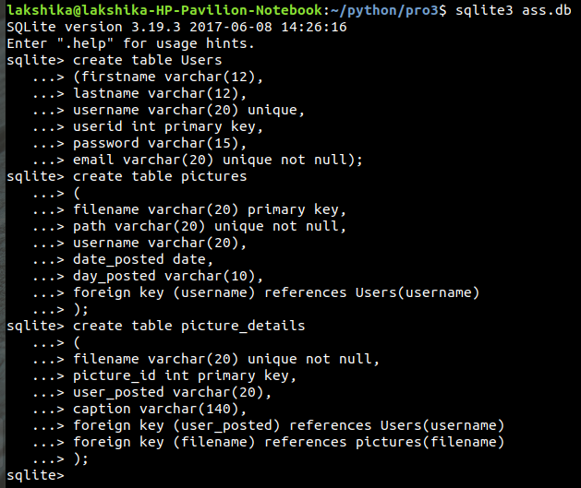**Creation of tables**

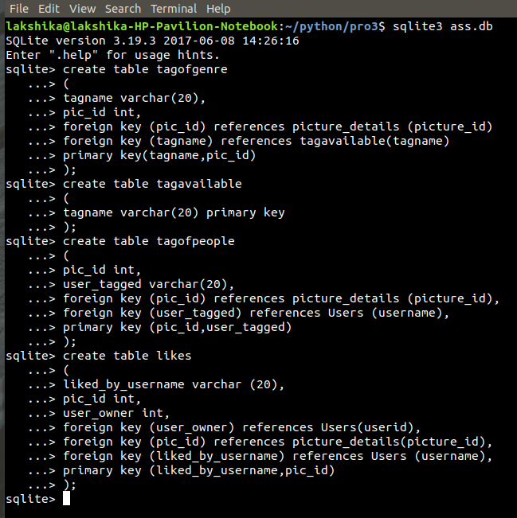

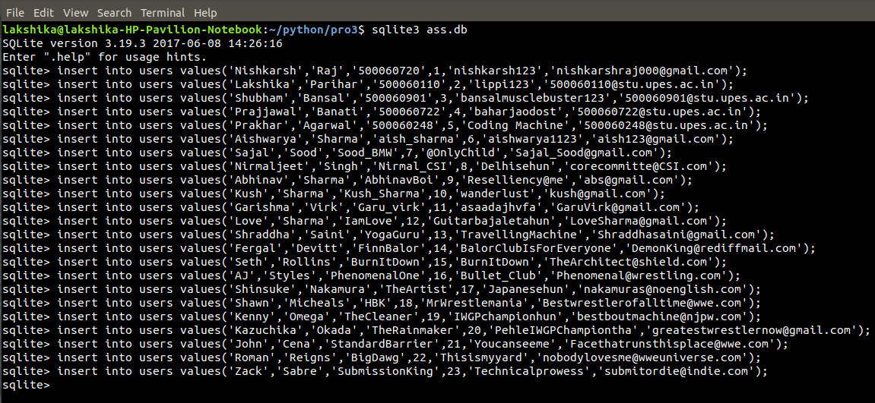**Screenshots-insertion**

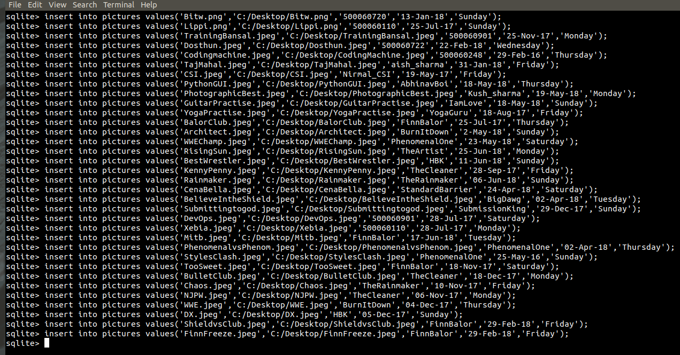

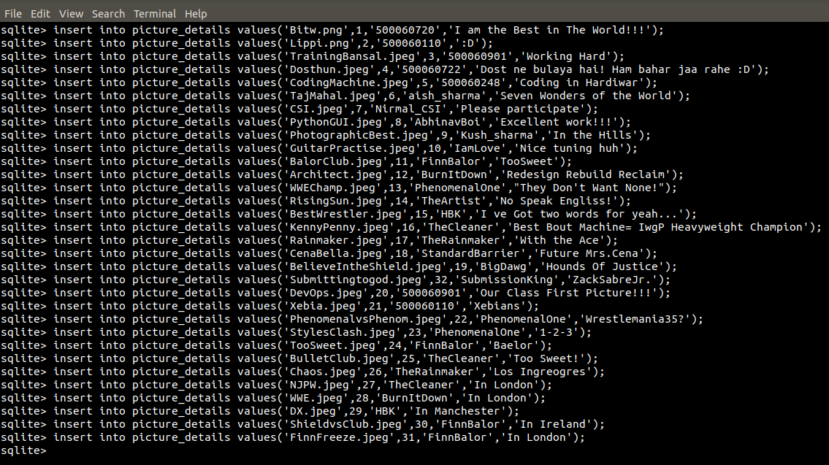

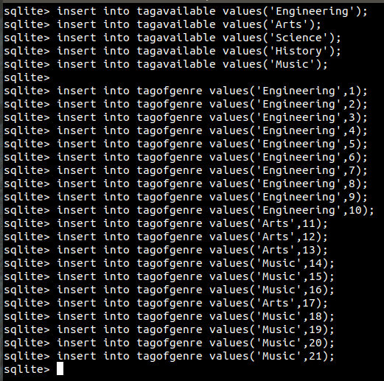

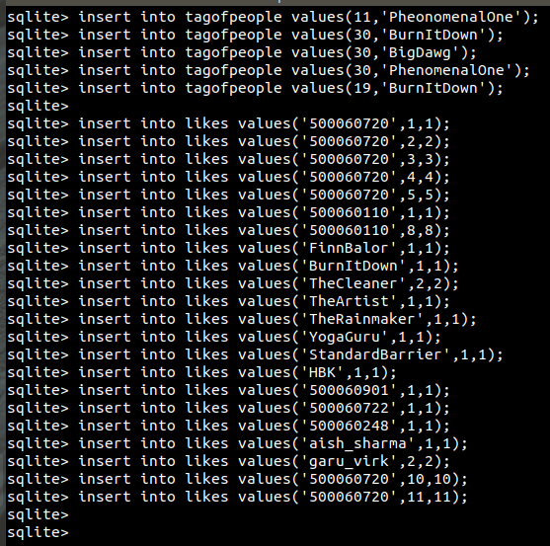

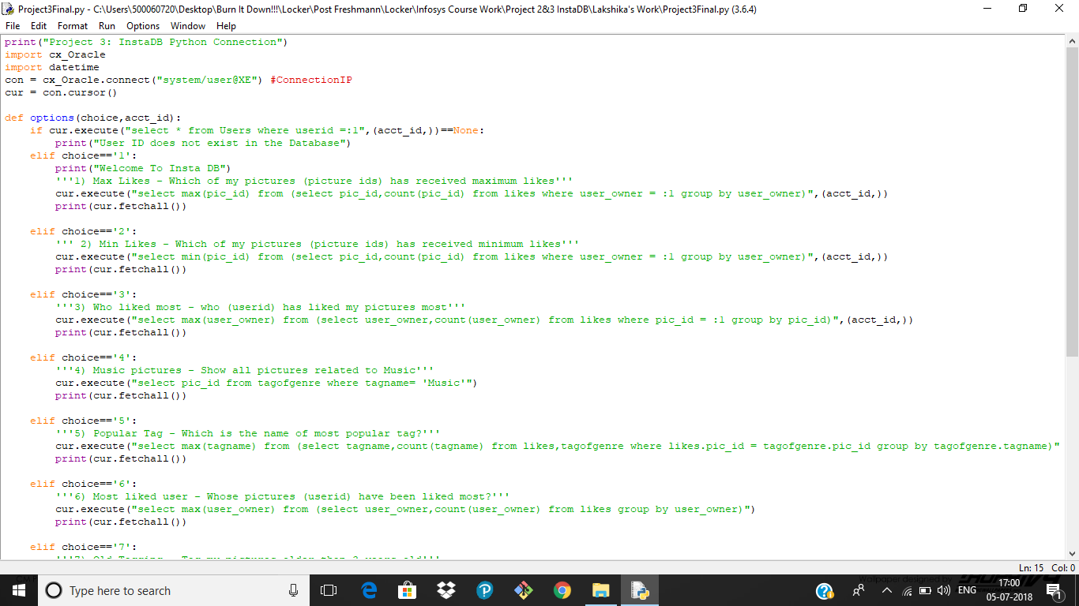**Screenshots of code**

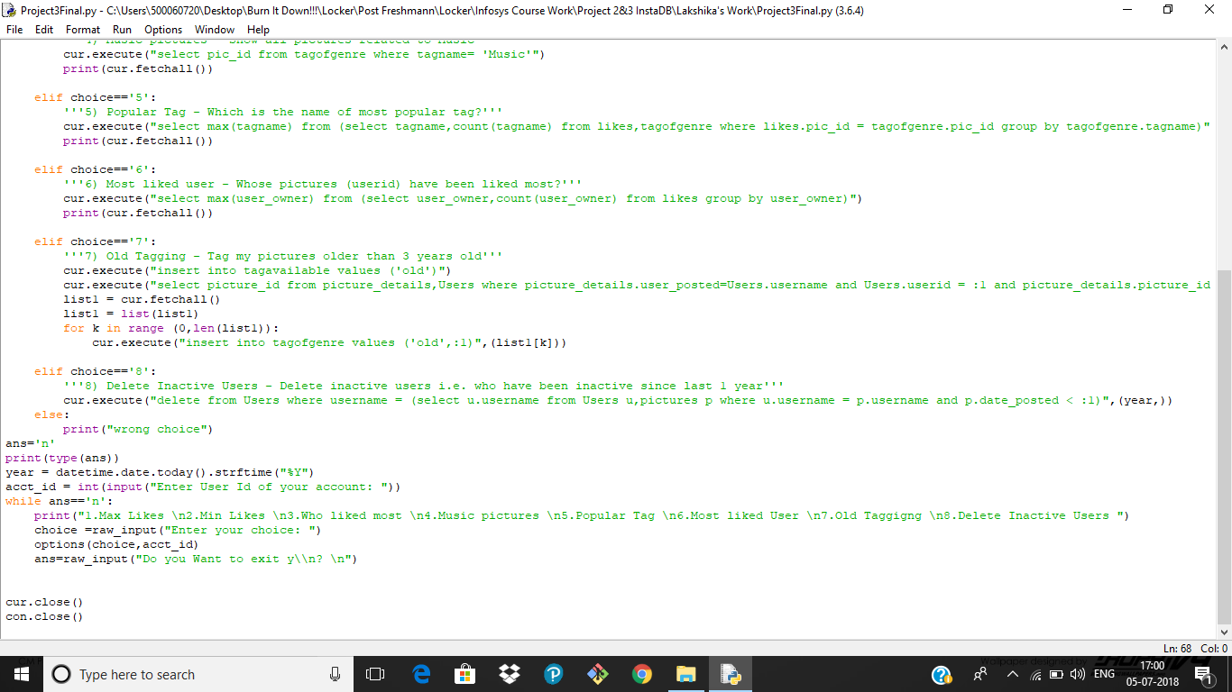

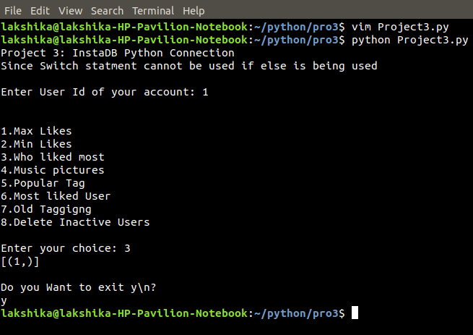**Screenshots- Final program**